Pentastic Jazz Festival
Sponsorship Information 2026
1 of 4

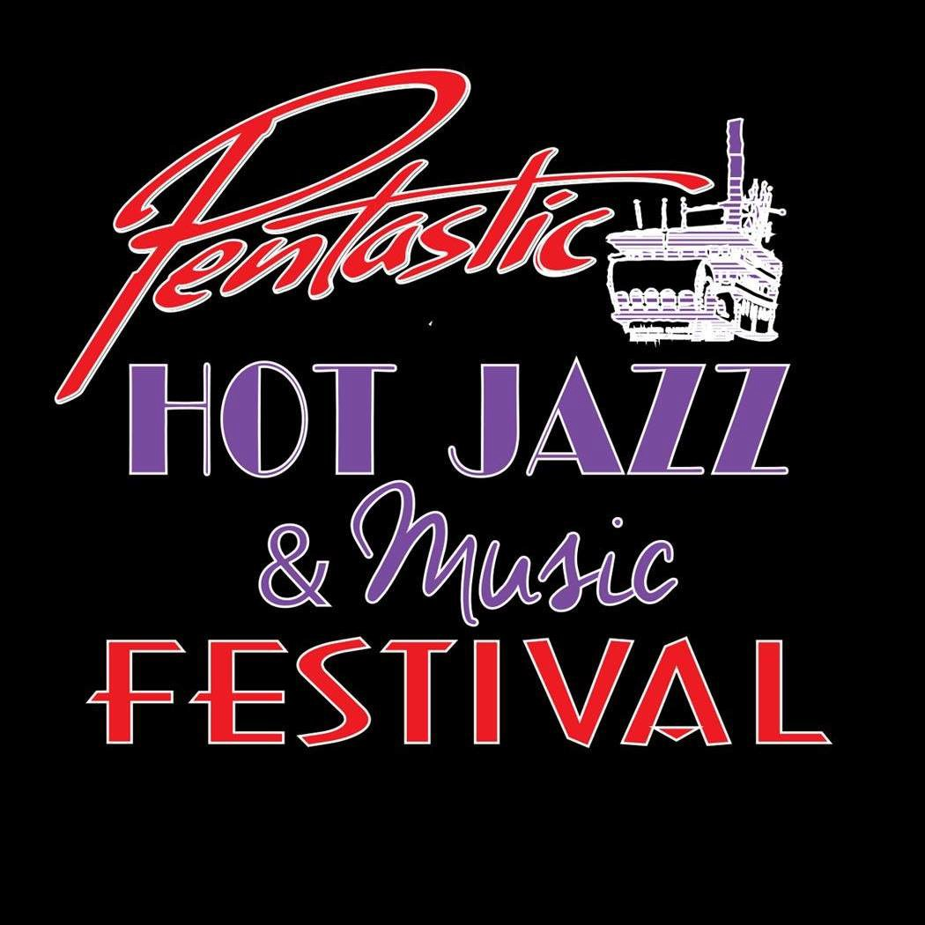
Pentastic Jazz and Music Festival

2026 Sponsorship Package

28TH Annual Jazz and Music Festival September 11th, 12th & 13th - 2026

COMMUNITY PARTNERSHIP LEVELS
Financial support from our Community Partners have supported this high caliber music festival for 27 years. Your continued support will enable us to produce the 28th festival and allow us to bring much needed tourism revenue to our beautiful city.
Without community partnerships, it would be impossible to produce this caliber of entertainment to be enjoyed by locals and visitors at reasonable prices.
The Pentastic Jazz Festival Society is solely dependent on resources from the Volunteer community as there are no individuals or groups that are paid employees.
As part of our commitment to participate in the community partnership program, we donate money to the Penticton Secondary School Band program through 2 silver collection proceeds.
Community Partners are recognized through festival program listings, rack cards, posters, media advertising, social media postings and other various communications. Signs and banners supplied by the Community Partner will be featured during the festival and on our website for some levels of sponsorship.
To show our appreciation of your ﬁnancial support, we invite you to join us for the Kick Oﬀ Party on Thursday, September 10th, 2026. Details to come.

Several levels of sponsorship are available. The Title sponsorship level through to Pla(num, Gold, Silver, Bronze and Friends will provide you with a choice of beneﬁts as listed below.
TITLE SPONSORSHIP: $5,000.00
- All collateral produced will feature your company name as the Presen(ng Sponsor
- Your logo and name will be placed on material distributed throughout the Paciﬁc Northwest, United States publications, BC Media, Social Media and our Website
- Full page advertisement and listing in the oﬃcial festival program.
Advertisement should be supplied to the festival designer by June 1, 2026 at: spiciredesign@telus.net. It should be in a PDF format (5.5w x 8.5h inches)
- Venue advertising (sponsor provided, please contact us for specs)
- Eight (8) All Event Weekend Passes – Value $1400.00
- Invitation for 2 to the Kick Oﬀ Party – Value $158.00
- A banner may be installed at the Penticton Trade and Conven(on Centre during the festival

PLATINUM LEVEL - $2,000.00

- Sponsor logo included on all advertising collateral.
- Full Page advertisement in the oﬃcial festival program. Advertisement to
be supplied by the sponsor and e-mailed by June 1, 2026 to the festival designer at: spiciredesign@telus.net in a PDF format (5.5w x 8.5h inches).

- Six (6) All Event Weekend Passes – Value $1050.00
- 2 Kick Oﬀ Party Tickets – Value $158.00
- Lis(ng and Logo as supplied by sponsor on the festival website with a link
To the sponsor’s own website
- Sponsors may also install a banner at the Penticton Trade and Conven(on Centre during the festival weekend.

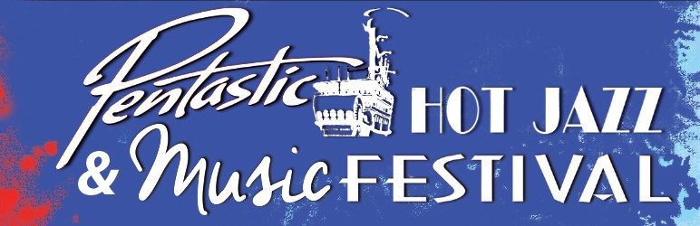

GOLD LEVEL: $1,000⁺
- Venue advertising (Sponsor provided - size limitation – please contact us for specifications).
- Four x 3 Day All Event passes. Value of $700.00.
- Invitation for 2 to the Festival’s “Kick-Off Party” on Thursday, September 10th, 2026. Value of
$158.00
- Listing, as provided by sponsor, on festival website - www.pentasticjazz.ca , with a link to sponsor’s own web page.
- Listing in the festival official program & optional Display sign at Penticton Trade & Convention Center

SILVER LEVEL: $750⁺
- 2 All Event passes. Value of $350.00
- Invitation for 2 to the Festival’s “Kick-Off Party” on Thursday, September 10th, 2026. Value of $158.00
- Listing, as provided by sponsor, on festival website www.pentasticjazz.ca and in the official Festival program.
- Listing in the festival official program & Display sign at Penticton Trade & Convention Center

BRONZE LEVEL: $500⁺
- Two x 3 Day All-Event-passes. Value $350.00
- Invitation for 2 to the Festival’s “Kick-Off Party” on Thursday, September 10th, 2026. Value of
$158.00
- Listing, as provided by sponsor, on festival website www.pentasticjazz.ca and in the official Festival program.

FRIENDS OF THE FESTIVAL: DONATIONS UP TO $500⁺

1. Listing, as provided by sponsor, on festival website www.pentasticjazz.ca and in the official Festival program.

Pentastic Jazz Festival
Sponsorship Information 2026
4 of 4

Sponsor Commitment Form

Please print and complete and forward to us by email or mail.

All sponsorship $ would be appreciated by June 1st, 2026. The Society will issue invoices if requested.

Company/Individual Name
Sponsorship Level
Name as it should appear on the Pentastic website
Mailing address
Website address
Contact person name
Contact person email
Phone number

The fine print:
- We understand that this letter will allow the Society to include us as sponsors on their web site immediately as well as in the Festival Program and advertising appropriate to our level of support. Please provide your current logo for Platinum Sponsorship.
Email jpeg format logo to spitfiredesign@telus.net

Signed Date:

Completed forms can be emailed on www.pentasticjazz.ca or email to: support@pentasticjazz.ca
or mailed to:
The Pentastic Jazz Festival, 113-437 Martin Street, Box 386, Penticton, BC, V2A 5L1
Phone 250.770.3494
Thank You!

